SOLED

USER MANUAL

Volume 1.0

Table of Contents

Table Of Contents 1
Preface: 3
SOLED I 30 LED 5
SI 30 Technical Specifications: 5
Solar Modules Dimensions and Pole Details 6
SI 30 Packaging Information: 6
SOLED I 42 LED 8
S I 42 Technical Specifications: 8
S I 42 Solar Modules Dimensions and Pole Details 9
SI 42 Packaging Information: 10
SOLED II 60 LED 11
S II 60 Technical Specifications 11
SII 60 Packaging Information: 12
SOLED II 84 LED 13
S II 84 Technical Specifications 13
SII 84 Packaging Information: 14
Assembly Drawing (all models) 15
Special Components Needed: 17
Photovoltaic Cells (Solar Panels) 17
Installation Instruction for the SOLAR (PV) Module 18
Photovoltaic (PV) System Scheme: 18
Metallic Bracket: 18
Exposing to the Sun: 18
Setting and Fixing: 19
Wiring and Connection: 19
Module(s) maintenance and care 19
Cautions: 20
Solar Charger Controller 21
Characteristics 21
System main circuit diagram 22
Installation: 22
Work mode setting: 23
Time setting: 24
Problems & Troubleshooting: 24
Specifications: 25
Battery Pack 26
Please Locate Local suppliers with the following descriptions for Batteries. 26
Specifications 26
Features 26
Benefits of Catalyst in SEC VRLA Batteries 26
* Minimize water loss 27
* Increased life 27
* Minimize positive plate corrosion 28
* Maintain cell capacity 28
Rechargeable Battery Compatibility Chart (need citation) 28
Terminal voltage 29
Warning: 29
Warranty 30

Preface:

SOLE. Meaning; free from the interference of others, We also took the name of the sun in Swedish which is Sol and added the LEDs to it and came up with the name SOLED and the name says it all: Independent, energy saving, non-polluting Solar Lights that can give you years and years of night light without any operating expense.

SoLEDs can be used anywhere the Sun is shining. Combined with the U-Tron award wining design which is the proven technology for Lamps with very wide coverage of light at low heights, now can be used just with the solar panels and car batteries and forget about the electric bill and complicated power line wiring requirements. .

There are 6 components we need to address for a Solar Light System:
- LED luminaries
- Photovoltaic Solar Panel
- Re-Chargeable Batteries
- Controller
- Light Post
- Installation Kit: (brackets, Underground battery box, cables and special tools)

U-Tron SoLED solutions can be supplied with all you need to install the lamp. However, the light post and rechargeable batteries (highlighted in blue) can be purchased locally to avoid long distance shipping of non vital parts. We can give you reference table to identify the other brand rechargeable batteries that can be found in your area.

Due to the low efficiency (only 15% to 17%) of Solar light to electricity conversion we are forced to use very larger solar panels to capture the sun light. This may require proper installation of the heavy panels to withstand wind, rain, earthquakes and other natural disasters. At the same time you should pay attention to the direction and the tilted angle to best suite your local geographical location. The sun rise, sun set and yearly sun shining data can be found at our website: www.u-tron.com

Solar panel, rechargeable batteries and the controller box are third party products but covered under the same warranty of U-Tron. However, more information and installation tips can be found at the respective suppliers web sites.

SOLED I 30 LED
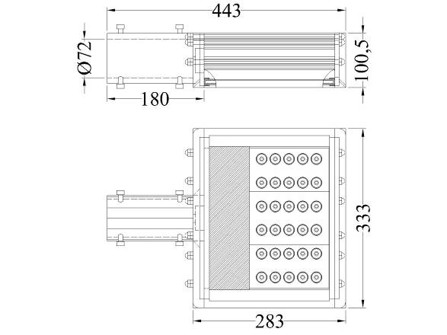
Figure 1

SI 30 Technical Specifications:
Number of LED 30 High Power Cree Q5 LED
Lumens 3,210 lm (107 Lumens per LED)
At 4 meters >55.75lx (average)
At 5 meters >35.67lx (average)
At 6 meters >24.77lx (average)
At 7 Meters Not recommended
Operating voltage 10 to 30 Volt DC
Solar panel 1382 x 1050 mm (2-130Watts Solar panels-designed for Sweden)
Battery Two 60 AH 12 V Automobile batteries connected in serial mode to give 24 V output.
Duration of operation Not less than 10 Hours for 3 consecutive nights when fully charged.
Controller functions Light control, over charge protection, over discharge protection, and dimming after xx hours of operation.

Solar Modules Dimensions and Pole Details

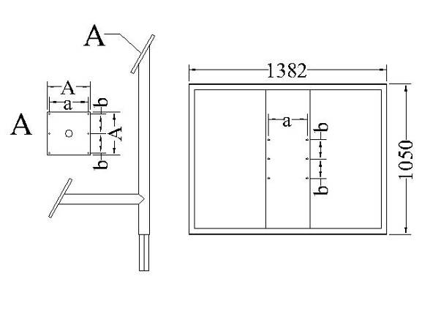
This solar module is designed according to the sunlight in Sweden, we have calculated that 40W LED light working ten hours a day need fit in two 130 Watts solar modules. (SOLED I 30 LED is only consume 34.5 Watts)

SI 30 Packaging Information:
Net Weight: 6.49 Kg
Gross Weight 8.41Kg
Carton Size (1 Pc/carton): 520mmx400mmx200mm

Container | Number of Pieces
20 Feet | 561
40 Feet | 1,166
40 Feet HQ | 1,378

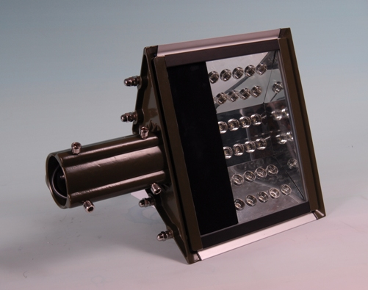
Figure 2

SOLED I 42 LED
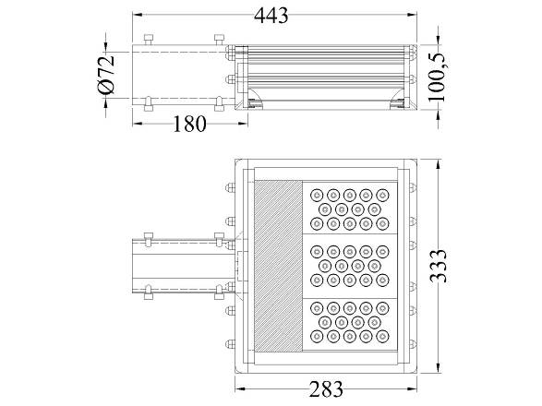
Figure 3

S I 42 Technical Specifications:
Number of LEDs 42 High Power Cree Q5 LED
Lumens 4,494 lm (107 Lumens per LED)
At 4 meters >78.05lx (average)
At 5 meters >49.95lx (average)
At 6 meters >34.69lx (average)
At 7 Meters >25.48lx (average)
Operating voltage 10 to 30 Volt DC
Solar panel 1470 x 680 mm (4-85Watts Solar panels – designed for Sweden)
Battery Two 60 AH 12 V Automobile batteries connected in serial mode to give 24 V output.
Duration of operation Not less than 10 Hours for 3 consecutive nights when fully charged.
Controller functions Light control, over charge protection, over discharge protection, and dimming after xx hours of operation.

S I 42 Solar Modules Dimensions and Pole Details

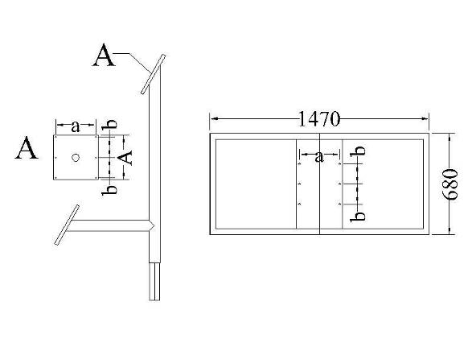
IN this example the solar module is designed according to the sunlight in Sweden, we have calculated that 50W LED light working ten hours a day need fit in four 85 Watts solar modules.(SOLED I 42 LED only consumes 48.3 Watts)

SI 42 Packaging Information:
Net Weight: 6.49 Kg
Gross Weight 8.41 Kg
Carton Size (1 Pc/carton): 520mmx400mmx200mm

Container | Number of Pieces
20 Feet | 561
40 Feet | 1,166
40 Feet HQ | 1,378

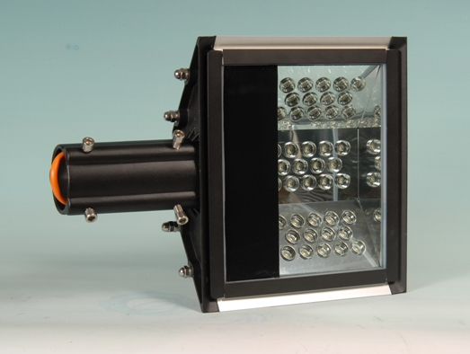
Figure 4

SOLED II 60 LED
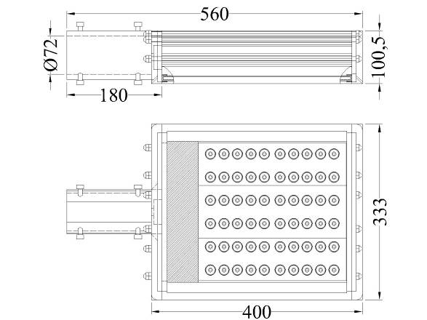
Figure 5

S II 60 Technical Specifications
Number of LEDs 60 High Power Cree Q5 LED
Lumens 6,420 lm (107 Lumens per LED)
At 4 meters >111.5 lx (average)
At 5 meters >70.0 lx (average)
At 6 meters >49.5 lx (average)
At 7 Meters >36.4 lx (average)
At 8 Meters >27.87 lx (average)
At 9 Meters >22.0 lx (average)
Operating voltage 10 to 30 Volt DC
Solar panel 1100 x 500 mm 4 panels
Battery Four 60 AH 12 V Automobile batteries connected in serial mode to give 24 V output.
Duration of operation Not less than 10 Hours for 3 consecutive nights when fully charged.
Controller functions Light control, over charge protection, over discharge protection, and dimming after xx hours of operation.

SII 60 Packaging Information:
Net Weight: 8.71 Kg
Gross Weight 11.07 Kg
Carton Size (1 Pc/carton): 640mmx400mmx200mm

Container | Number of Pieces
20 Feet | 561
40 Feet | 1,166
40 Feet HQ | 1,378

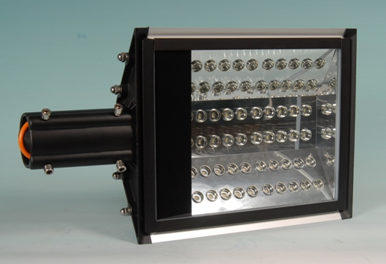

Figure 6

SOLED II 84 LED
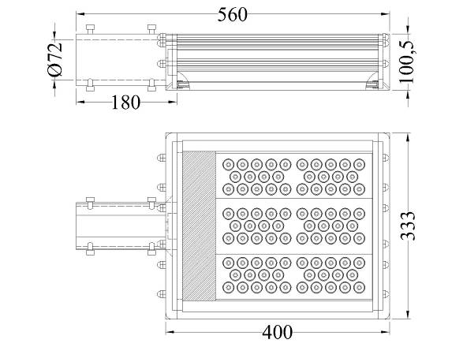
Figure 7

S II 84 Technical Specifications
Number of LEDs 84 High Power Cree Q5 LED
Lumens 8,988 lm (107 Lumens per LED)
At 4 meters >156.10 lx (average)
At 5 meters >99.90 lx (average)
At 6 meters >69.38 lx (average)
At 7 Meters >50.97 lx (average)
At 8 Meters >39.03 lx (average)
At 9 Meters >30.83 lx (average)
At 10 Meters >24.98 lx (average)
Operating voltage 10 to 30 Volt DC
Solar panel 1100 x 500 mm 4 panels
Battery Four 60 AH 12 V Automobile batteries connected in serial mode to give 24 V output.
Duration of operation Not less than 10 Hours for 3 consecutive nights when fully charged.
Controller functions Light control, over charge protection, over discharge protection, and dimming after xx hours of operation.

SII 84 Packaging Information:
Net Weight: 8.71 Kg
Gross Weight 11.07 Kg
Carton Size (1 Pc/carton): 640mmx400mmx200mm

Container | Number of Pieces
20 Feet | 561
40 Feet | 1,166
40 Feet HQ | 1,378

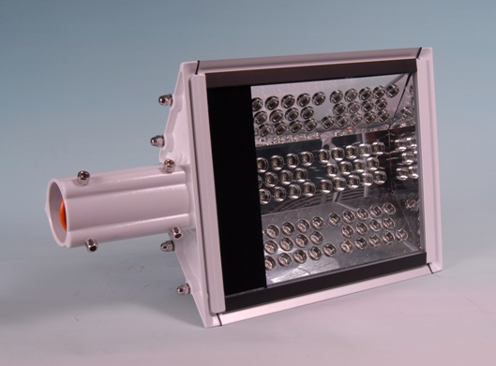
Figure 8

Assembly Drawing (all models)

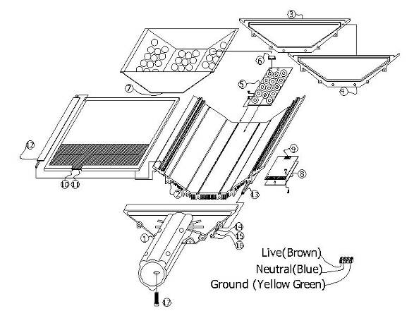
Figure 9

1- Head | 8 – Heat Transfer Sole | 15- M8 Split Lock Washer
2 - Main Frame | 9 – Driver Board | 16 – M8 Hex Cap Nut
3 - Tail | 10 – Glass Rubber | 17 – M10 Bolt
4 - Gasket | 11 – Glass Cover
5 – LED Board | 12 – Glass Holder
6 – LED Reflector Caps | 13 – M8 Stud
7 – LED Reflector Cover | 14 – M8 Flat Washer

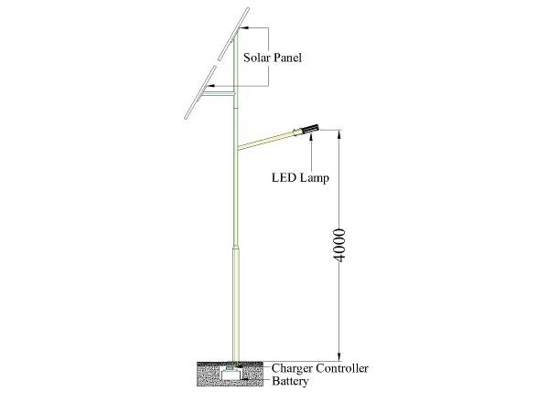

Installed SOLED 30 LED in a 4 meter high lamp post with 2-130 Watts Solar panel connected to the charger below the ground and 12V mobile battery.

Special Components Needed:

Photovoltaic Cells (Solar Panels)
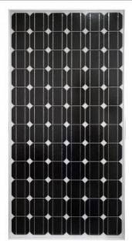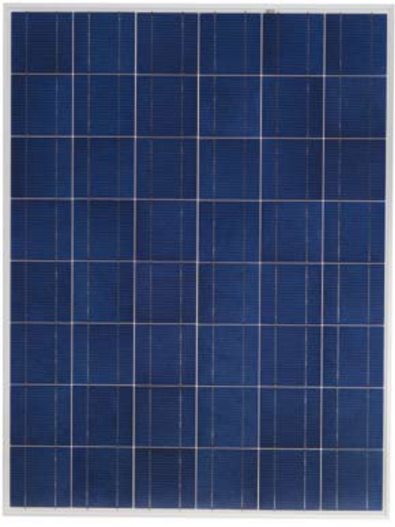
Mono-Crystal Solar Cell Polycrystalline Solar Cell

 | Characteristic |  | RE-30S
 | Peak Power (Pm): |  | 30
 | Open-Circuit Voltage (Voc): |  | 21.6
 | Short-Circuit Current |  | 1.83
 | Maximum Power Voltage |  | 18.0
 | Maximum Power Current |  | 1.67
 | Temperature coefficients of Isc (%) |  |  | + 0.1/ ℃
 | Temperature coefficients of Voc (%) |  |  | -0.38/ ℃
 | Temperature coefficients of Pm (%) |  |  | -0.47/ ℃
 | Warranty |  |  | 20 Years
Configuration |  | 12V
Maximum system voltage (V) |  | 715VDC
Operating Temperature |  | －40℃～+85℃

Installation Instruction for the SOLAR (PV) Module

Photovoltaic (PV) System Scheme:

Solar Charge Controller

LED Street
Light

Battery

(Array of PV Module)

Metallic Bracket:
PV modules need at least more than 2 people to install, and may require special vehicles equipped with lifts and or ladders depending on the size, and heights of your lamp post. . You can also mount on the roof or on the ground depending on the actual conditions of your surroundings. U-Tron will not take any responsibility for improper installation of the Solar panels. The users should get professional help when building their own light post and bracket for the PV modules. The size and recommended installation holes are given in this document at each module. You are recommended to purchase suitable bolts and nuts at your local hardware stores. (see the Setting and Fixing section for the nut and bolt size)

The following two considerations are important for design and construction of the Support Mounting brackets:
To avoid damage from flooding and other unpredictable events, and avoid heavy impact.
To design a gradient angle facing the sun radiation direction in order to insure the full sunshine receives as much as possible. Visit www.u-Tron.com for more detail.

Exposing to the Sun:
The solar modules array should be installed facing the south and form a certain angle to horizon, to ensure the radiation-receiving surface of the modules vertical to the direction of the sun incidence.
Always ensure that no shadow from the buildings, trees, cables etc cover any part of the module(s).

Setting and Fixing:
To prevent water ingress into the junction box it is recommended that the module(s) be installed with the junction box located at the top. Use stainless steel screws and mounting brackets. Screws to be 8.0 mm, and 20.0 mm long to ensure adequate fixing.
At first, ensure that the screw holes for fixing (backside of the modules) are on straight line of sight and concentric with the mounting hole of the brackets.
Then tighten all the six screws with stainless steel screwdriver
IMPORTANT—all the six screws must be tightened carefully.

Wiring and Connection:
- Before this procedure, please read the operation instructions of the PV control system carefully.
- Make wiring by Multi–connecting cables between the PV modules in series or parallel connection, which is determined by user’s configuration requirement for System Power, Current, and Voltage.
- Open the connection box of the Control system and connect the cables from the PV Arrays to the Connection Box in accordance with the installation indication of the PV control systems.

Module(s) maintenance and care
- A build up of dust or dirt on the module(s) front face will result in a decreased energy output. Clean the panel(s) preferably once per annum if possible (dependant on site conditions) using a soft cloth dry or damp, as necessary.
- Never use abrasive material under any circumstances.
- Examine the PV module(s) for signs of deterioration. Check all wiring for possible rodent damage, weathering and that all connections are tight and corrosion free. Check electrical leakage to ground.
- Check fixing screws and mounting brackets are tight, adjust and tighten as necessary.

Cautions:
To avoid water leakage, keep the connection box closed and sealed once completed the wiring connection.

To prevent from lightning strike, if necessary, please install the lightning conductor on the PV Array.
The +/- polarity of the PV modules must not be connected in reverse.

Although its not life threatening (12V DC) but avoid touching both positive pole (+) and the negative (-) of the modules and array at the same time. The dangerous electric shock can happen when the installation work is exposed directly into the sun. The installation work of the PV array can only be done under the protection of sun–sheltering covers or sunshades and only qualified personnel can install or perform maintenance work on this module

Follow the battery manufacture’s recommendations if batteries are used with modules.

All instructions should be read and understood before attempting to install, wire, operate, and maintain the module.

Solar Charger Controller
U-Tron SOLAR CHARGE CONTROLLER (6830-100-S0)
Operating instructions:

Characteristics

Control circuit: use MCU and professional software as the control center to fulfill intelligent system control.

Charging mode: use PWM high efficiency charging way. Boost, recovery and float charging auto work for battery long-life. Use temperature compensation.

High accuracy over discharging control by the discharging rate: Over-discharging control voltage modified by the battery discharging rate curve.

Self protection: protection to overload, outside and inside short circuit, reverse connection, thunder and lightning, PV panel reverse current, over charging and discharging etc. during the short circuit and overload protection, no any component will be damaged and need change, include fuse.

LED indication on system condition: LED indicating the system of charging, overcharge, power full, power low, over-discharge, over load, out short circuit, load on/off, etc.

Industry level production standard: wide temperature running area -35℃ to +50℃

No adjustable hardware part: use flash memory to save all work control point instead of adjustable resistance, to protect the control work point from going off as the adjustable resistance value is easily changed by temperature and vibration, in order to make sure the control accuracy and reliability.

Operation: easy to operate, robust in design.

Two output modes: direct current output mode and 1HZ output mode. The1HZ output mode is very suitable for traffic caution light.

Controller Panel Indications
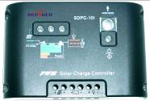

PV LED Bat
System state
LED(2)
PV charge
LED(1)
Short circuit
LED(3)
ON/OFF
Button
Work mode
Digit set key
PV charge
LED(1)

System main circuit diagram
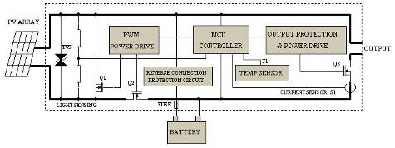
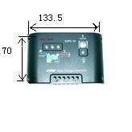

Installation:

a. Fix the controller in a certain place of the installing hole :
Size: 140 ×90.5(mm) Length between installing holes:133.5×70(mm)

b. Prepare wire. Choose the plastic Copper wire. Current density not more than 4A/mm². Cut the suitable length of wire and make it as shout as possible. Peel off 5mm the plastic at the end of wire.

c. Connect the wire to the battery port on the controller to the battery. Pay attention to the +, - pole of the connection. If the pole is reverse, it does not work. It has the function of self protection, and there is no any part will be damaged during this step, but should correct this mistake.

d. Connect the wire to the PV port on the controller to PV panel. If the connection is correct and the PV panel gets the sunlight, charging indicator will be light.

e. Connect the load to the load port on the controller. Attention the +, - pole should be correct.

!! Attention: during the installation, if the voltage of the system is 24V, you can not use the hands to touch any conductor in the system circuit in order to protect from electric shock.

Using:

Charge & overpressure indication：If the system is properly connected, when sunlight shines on the PV panel, the charge LED lights in green，indicating the system is working in a good order. PWM mode is applied in charging. During the charging, if over discharge has happened, firstly the voltage for charging battery will be up to boost voltage and keep 10 minutes, then returns to direct voltage and keep 10 minutes to activate battery, lastly to float voltage and keep this state for the best state of battery. This process is benefit to battery full charging and its life -span.

Battery state: when the battery voltage is in normal condition, the state LED lights in green; state LED flashes slowly in green when battery finishes its charge; When the voltage of the battery is lower, it will get in yellow color. When the voltage goes down continuously to over discharge, the System state LED will get in red color, and turns off the output at the same time, until the battery voltage recovers to over discharge return voltage, the system will work again automatically.

Load indication: the load LED lights when the load works. If the load current is 1.25 times higher for 60 seconds or 1.5 times higher for 5 seconds than rated current of the controller, the trouble LED flash slowly in red to show overload happened, and the controller will shut down output. When load short circuit happens, the trouble LED will flash quickly, then the controller will shut down its output. When it happens, please check if the load is properly connected. Disconnect the load at fault and press the button it will resume its work in 30 seconds or in another day.

Work mode setting:
Way of setting: press the on & off button for 5 seconds long until the number on the LED screen begins to flash. Press the button to choose a proper number. When the number no longer flashes, the setting is completed. Press the button to check the value.

Light ON+ Light OFF control mode: The load will start working when it gets dark until it gets bright or to the end of a setting time. There will be a 10 mins delay before turning on the load in order to make sure if it really gets dark.

Light ON + set time delay OFF mode: the start process same with above. Load will be closed after the setting time. Setting time can be seen in time setting table.
Common controller mode: The controller will work as a common controller, no light and time control, no ON and OFF delay time. only has the else function. If no sunlight on PV panel, it will turn on load at once; If sunlight on PV panel, it will turn off load at once.

Test mode: It used for the Light control system installed test. Only cancel the ON and OFF delay

Two Output modes: when the number displayed on the LED is anyone from 1 to 7, it is in Direct output mode; when the number is decimal from 0.1 to 7.0, it is in 1HZ output mode. LED can be directly started to display the 1HZ output mode. Start the pure resistance load in 1HZ output mode. Forbid using 1HZ output mode on capacitive or inductive load.

Time setting:
Work mode | LED |  | Work mode | LED
Light ON+ Light OFF | 0 | 0 | Light ON +10 Hour delay OFF | 4 | 4
Light ON + 4Hours delay OFF | 1 | 1 | Light ON +12Hours delay OFF | 5 | 5
Light ON + 6Hours delay OFF | 2 | 2 | Common controller | 6 | 6
Light ON + 8Hours delay OFF | 3 | 3 | Test no delay | 7 | 7
output mode | D C | 1HZ | output mode | D C | 1HZ

Problems & Troubleshooting:
Problems | Troubleshooting
The charge LED indicator doesn’t light in green when sunlight gets the PV panel. | Check if the cable of solar panel connects properly.
The charge LED indicator flash quickly . | System over voltage or open circuit of the battery. check if the battery connects to the system cable properly or the charging circuit damaged.
The load LED indicator light but there is no power output. | Check if the load connects to the system properly.
The load LED indicator flash quickly and there is no power output . | Check output circuit .If the load short or over load occurs, remove the load and push the button and the controller will resume its work after 30 minutes.
The load LED indicator light slowly and there is no power output. | Overload occurs, remove some loads and push the button again and the controller will resume its work after 30 minutes.
System state LED indicator flash in red color and there is no power output. | Over discharge of the battery. The controller will resume its work after finishing charge of the battery.

Specifications:
Type | SDRC5(I) | SDRC-10(I) | SDRC-20(I)
Rated charge current | 5A | 10A | 20A
Rated load current | 5A | 10A | 20A
Work voltage | 12v; 12/24V Auto
Over load, short circuit protection | 1.25 rated load current 60sec, 1.5 rated loads current 5sec, over load protection action. ≥3 Rated load current short circuit protection action.
No load current | ≤6mA
Charging circuit voltage drop | ≤0.26 V
Load circuit voltage drop | ≤0.15 V
Over voltage protection | 17V; ×2/24V
Work temperature | Industry stage：-35℃ to +55℃；
Boost charge voltage | 14.6V；×2/24V； (keep 10min)
Direct charge voltage | 14.4V; ×2/24V； (keep 10min)
Float charge voltage | 13.6V; ×2/24V；
charge return voltage | 13.2v;×2/24V；
Temperature compensation | -5mv/℃/cell (Boost charge, Direct charge, Float charge, charge return voltage);
Lower voltage indicate | 12.0V； ×2/24V；
Over discharge voltage | 11.1V（no load）- real-time modified voltage by the discharge rate； ×2/24V；
Over discharge return voltage | 12.6V; ×2/24V
Control mode | PWM charge mode; modified discharge voltage by the discharge rate

Battery Pack
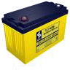

Please Locate Local suppliers with the following descriptions for Batteries.
6 mm Female Terminal - FT 4 = 16 mm with M6 Bolt
8 mm Female Terminal - FT 5 = 16 mm with M8 Bolt

Specifications
POSITIVE PLATE: Lead calcium flat plate grid
NEGATIVE PLATE: Flat pasted grid
ELECTROLYTE: Sulphuric acid or thixotropic Gel
CATALYST VENT: Catvent (optional)
CONTAINER: Grade ABS V-0
SEPARATORS: Microporous separator
FLOAT VOLTAGE: 2.25 vpc at 20/25oC
MAX CHARGE VOLTAGE: 2.35 vpc at 20/25oC
SAFETY ONE WAY VALVE: 1-3 p.s.i self-resealing
TERMINALS: Integral heavy duty brass inserts
INTERCONNECTS: Copper bar or cables

Features
Maintenance Free
Front terminal battery
Tank formed flat Calcium plates
Manifolded gasing system
Incorporates precious metal catalyst Catvent

Benefits of Catalyst in SEC VRLA Batteries
Catalyst Reduces Float Current
One of the most immediate, observable effects of installing a catalyst in a VRLA cell is a sudden drop in the float current. Typically float currents are one half or less when a catalyst is installed. Adding a catalyst to the cell prevents some of the oxygen reaching the negative plate and allows the negative plate to stay polarised. This means that less current needs to be supplied to the cell from the charging system, manifesting itself as lower float current, leading to the following benefit :-

* Minimize water loss
Gasses are recombined into water inside the cell rather than exiting the cell. Too much gas leaving the cell can lead to premature dry-out and cell failure. Cell dry out has been predominant cause of customer dissatisfaction with VRLA technology.

* Increased life
There are many potential failure modes of VRLA cells. A number of these failure modes can be mitigated by the catalyst technology such as: Cell dry out, positive plate corrosion, thermal runaway, capacity loss due to negative plate depolarization.

* Minimize positive plate corrosion
A reduction in float current reduces the amount of over- charge on the positive plate which directly impacts the corrosion rate. The design life of a lead acid cell is based on the corrosion of the plate barring any other unforeseen failure modes.

* Maintain cell capacity
Many VRLA cells in service are failing capacity tests because their negative plates are depolarized In fact significant capacity increases have been seen on some cells just by installing a catalyst.

Rechargeable Battery Compatibility Chart (need citation)

Country | Brand | Model and AH size | Where to buy
USA | Excide | PCM - 70 | 1-800-456-2965
 | Eveready
 | Lucas
 | Duracell
Chile | OPTIMA
Sweden | Excide
China | DongFang

Terminal voltage
Open Circuit Voltage (12 V) | Open Circuit Voltage (6 V) | Approximate charge | Relative acid density
12.65 V | 6.3 V | 100% | 1.265 g/cm³
12.45 V | 6.2 V | 75% | 1.225 g/cm³
12.24 V | 6.1 V | 50% | 1.190 g/cm³
12.06 V | 6.0 V | 25% | 1.155 g/cm³
11.89 V | 6.0 V | 0% | 1.120 g/cm³

Warning:

Rechargeable batteries can explode if left unattended or missed used and can cause bodily damage.

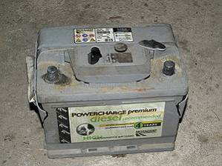

Please visit the following links for understanding more about the rechargeable batteries:

Autobatteries.com Frequently Asked Questions

batteryuniversity.com An on-line resource that provides practical battery knowledge

Warranty

U-Tron (Beijing) Electronics Co. Ltd., warrants the products listed below for a period of 36 months from the date of shipment to be free from defects in materials or workmanship and to be of the kind and quality designated or specified in the purchase agreement. If any product dose not meets the above warranty and the buyer promptly files a warranty claim U-Tron shall do the following:
U-Tron shall provide a 12 months “No Questions Asked” replacement of any faulty units at no charge to the customer. The time limit for exchange shall not exceed 30 days from the time a claim is filed by the buyers. The buyers shall return the faulty units within 30 days of filing the claim. The method of shipping back the faulty units to U-Tron shall be decided at that time by U-Tron and all shipping charges shall be borne by U-Tron.
At the end of the 12 month period U-Tron shall provide additional free extended warranty for another 24 months. During this 24 months time U-Tron shall repair or replace and re-certify every faulty unit reported. Shipping charges for sending the units to U-Tron shall be the responsibility of the Buyers and the shipping charges to return the repaired goods to the buyer shall be borne by U-Tron. Thetime limit for repairs shall not exceed 60 days.
U-Tron at its own option can elect to provide replacement units at any desired percentage to be warehoused and logged by the buyers for timely service of the extended warranty replacements. When the warranty expires the faulty units and the unused units shall be shipped back to U-Tron unless otherwise stipulated in the contract or purchase agreement. If 90% of the warehoused units are used up or nearing the end of stock, the buyers shall ship back the faulty units to U-Tron. U-Tron shall rotate the spare parts inventory within 60 days of receiving from the buyers.
All warranty claims items shall by shipped to the buyers regardless of the geographical location, by air freight to the nearest airport, and any returning items can be shipped by sea or air freight at the request of U-Tron. If the customer fails to return the said faulty units with in the time frame as instructed, it will be considered as sold and U-Tron reserve the rights to bill the customer for its full value.
U-Tron shall not bare any responsibilities with the buyers customer claims or shall not bare any other expenses incurred other than the units cost it self. Customer site de-installation and re-installation of any faulty units shall not be the responsibilities of U-Tron.
The warranties set forth herein shall be voided if the units have been: 1) Repaired or altered by any unauthorized person. 2) Subjected to misuse, negligence or accidents or operated in other than normal operation and use. 3) Connected, installed or modified in a manner not in accordance with U-Tron instructions.

Applicable models under this warranty:
Street LED Lamps | LED Traffic Lights | Signal Control Products
All Models | All Models | All Cabinet accessories
Copyright © 2008-2009 U-Tron (Beijing) Electronics Co. Ltd., All rights reserved. The information in this document is subject to change without notice. U-Tron and U-Tron logo are trade marks of U-Tron (Beijing) Electronics Co. Ltd., CREE, Linear Technology, National Semiconductor and any other logos are trade marks of the respective companies and owners and U-Tron do not imply any endorsement or association for these trademarks.

